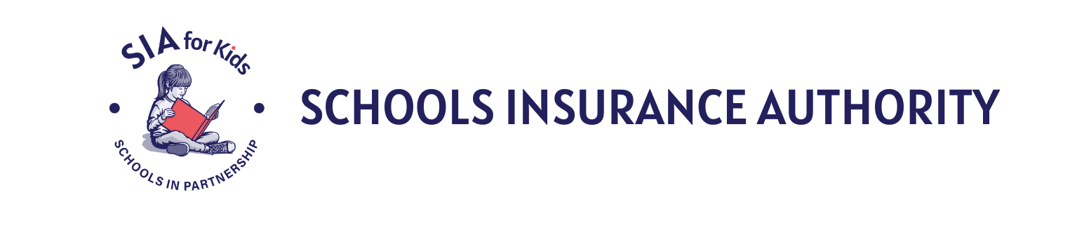

EXECUTIVE COMMITTEE MEETING
AGENDA

Thursday, October 15, 2026, 9:00 AM
9800 Old Placerville Road, Suite 100 Sacramento, CA 95827

FOR PUBLIC WISHING TO ATTEND, email Amanda Franco at afranco@sia-jpa.org.
Disclaimer: All items appearing on the agenda are subject to action. Staff recommendations are subject to change by the legislative body.

- CALL TO ORDER – Frederickson

- PUBLIC COMMENTS – Frederickson
At this time, members of the public may address the Executive Committee regarding any items within the subject matter jurisdiction of the Committee, provided that NO action may be taken on off-agenda items unless authorized by law. Comments shall be limited to five minutes per person and twenty minutes for all comments unless different time limits are set by the President subject to the approval of the Committee.

- COMMUNICATIONS – Rice

- CONSENT CALENDAR / ACTION – Frederickson
  - Agenda
  - Minutes – September 10, 2026
  - Expense Report – April, May, June 2026
  - Personnel Actions

- GENERAL BUSINESS OF THE COMMITTEE
  - Executive Report / Information – Rice
  - SIA Financial Report – as of June 30, 2026 / Information – Russell
  - SIA Cash / Investment Report – June 30, 2026 / Information – Brown
  - Consider MOLC Changes / Information – Nelson
  - Acceptance of the 2026 Cyber Program Actuarial Report / ACTION– Brown
  - Prevention Department Update / Information – Rice
  - Risk Management Department Update / Information – Serran/Costamagna
  - Other – Frederickson

- CLOSED SESSION
  - Discussion of Claims Pursuant to Government Code Section 54956.95:
    - Workers’ compensation claims closed in excess of $50,000 – Gouveia
      - Anderson v. Elk Grove Unified SD

    - Liability claims settled in excess of $25,000 – Nelson
      - Millard v. Galt Joint Union High SD
      - Fabel v. San Juan Unified SD
      - SS v. Folsom-Cordova Unified SD

- REPORTING OF CLOSED SESSION ACTIONS – Frederickson

- ADJOURNMENT – Frederickson

UPCOMING MEETING

Executive Committee Meeting &
Strategic Planning Sessions
Thursday, November 12, 2026, 9:00 AM
9800 Old Placerville Road, Suite 100 Sacramento, CA 95827

NOTICE TO THE PUBLIC:
If you have any questions on the agenda, please contact the Schools Insurance Authority at 916-364-1281. Agendas are available at www.sia-jpa.org.

All public records relating to an open session item on this agenda which are not exempt from disclosure pursuant to the California Public Records Act and which are distributed to a quorum of the legislative body will be available for public inspection at 9800 Old Placerville Road, Suite 100 Sacramento, CA 95827 at the same time that the public records are distributed or made available to the legislative body.

Copies of publicly disseminated materials may be requested; copying or transmittal charges will be at the requester's expense. Some or all of the meetings may be electronically recorded.

Any person(s) requiring accessible formats of the agenda or disability-related modification or accommodations, including auxiliary aids or services to enable individuals with disabilities to participate in this meeting, should contact Schools Insurance Authority at 916-364-1281at least one (1) full business day in advance of the meeting.

