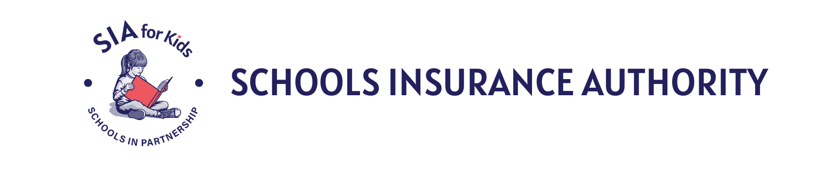

EXECUTIVE COMMITTEE MEETING
AGENDA

Thursday, April 9, 2026, 9:00 AM
9800 Old Placerville Road, Suite 100 Sacramento, CA 95827

Public Virtual Participation: (669) 900-6833 - Meeting ID: 896 6323 8987 - Passcode: 124486
https://sia-jpa-org.zoom.us/j/89663238987?pwd=RDA7iOuY4XHvyrhJiRNhvFOOQ0Pw6a.1&from=addon

FOR PUBLIC WISHING TO ATTEND, email Amanda Franco at afranco@sia-jpa.org.
Disclaimer: All items appearing on the agenda are subject to action. Staff recommendations are subject to change by the legislative body.

- CALL TO ORDER – Frederickson

- PUBLIC COMMENTS – Frederickson
At this time, members of the public may address the Executive Committee regarding any items within the subject matter jurisdiction of the Committee, provided that NO action may be taken on off-agenda items unless authorized by law. Comments shall be limited to five minutes per person and twenty minutes for all comments unless different time limits are set by the President subject to the approval of the Committee.

- COMMUNICATIONS – Rice

- CONSENT CALENDAR / ACTION – Frederickson
  - Agenda
  - Minutes – February 12, 2026 and March 12-13, 2026 (Planning Meeting)
  - Personnel Actions

- GENERAL BUSINESS OF THE COMMITTEE
  - Executive Report / Information – Rice
  - Cyber Program Strategic Planning / Information – Brown
  - CAJPA Accreditation Report and Acceptance / ACTION – Rice
  - Resolution Admitting Butte Schools Self-Funded Programs JPA / ACTION – Rice
  - SIA Memorandum of Cyber Coverage (MOCC) Changes / Information – Brown/Rice
  - Approve Investment Policy / ACTION – Brown
  - SIA Executive Committee Volunteer Sub-Committee 2026/27 Appointments– Audit, Budget, Nominating, and Personnel / Information – Rice
  - SIA Executive Committee Calendar dates for 2026/27 / Information – Rice
  - Prevention Department Update / Information – Konarski
  - Risk Management Department Update / Information – Serran/Costamagna
  - Other – Frederickson

- CLOSED SESSION
  - Discussion of Claims Pursuant to Government Code Section 54956.95:
    - Workers’ compensation claims closed in excess of $50,000 – Gouveia
      - Cain v. Elk Grove USD
      - Johnston v. Arcohe Union Elementary SD
      - Castillo v. Hayward Unified SD

    - Liability claims settled in excess of $25,000 – Nelson/Bozio/Reynolds
      - MJ v. North Sac. Elementary (Twin Rivers Unified SD)
      - Fletcher v. San Juan Unified SD
      - Fisher v. San Juan Unified SD
      - Castro v. Twin Rivers Unified SD
      - Zavala Flores v. Sacramento City Unified SD

- REPORTING OF CLOSED SESSION ACTIONS – Frederickson

- ADJOURNMENT – Frederickson

UPCOMING MEETING

Executive Committee Meeting
Thursday, May 14, 2026, 9:00 AM
9800 Old Placerville Road, Suite 100 Sacramento, CA 95827

NOTICE TO THE PUBLIC:
If you have any questions on the agenda, please contact the Schools Insurance Authority at 916-364-1281. Agendas are available at www.sia-jpa.org.

All public records relating to an open session item on this agenda which are not exempt from disclosure pursuant to the California Public Records Act and which are distributed to a quorum of the legislative body will be available for public inspection at 9800 Old Placerville Road, Suite 100 Sacramento, CA 95827 at the same time that the public records are distributed or made available to the legislative body.

Copies of publicly disseminated materials may be requested; copying or transmittal charges will be at the requester's expense. Some or all of the meetings may be electronically recorded.

Any person(s) requiring accessible formats of the agenda or disability-related modification or accommodations, including auxiliary aids or services to enable individuals with disabilities to participate in this meeting, should contact Schools Insurance Authority at 916-364-1281at least one (1) full business day in advance of the meeting.

