Guidelines for Addressing a Potential Workplace Exposure to COVID-19
Contents
1. EMPLOYEE 2
2. MANAGER/SUPERVISOR 3
REPORT: EMPLOYEE REPORTS SYMPTOM(S) CONSISTENT WITH COVID-19 3
REPORT: EMPLOYEE BECOMES SICK DURING THE WORK DAY 3
REPORT: EMPLOYEE REPORTS POSSIBLE EXPOSURE TO COVID-19 CASE 3
REPORT: EMPLOYEE REPORTS MEDICAL DIAGNOSIS OF COVID-19 WITHOUT CONFIRMED TEST 3
REPORT: EMPLOYEE GIVEN MEDICAL DIAGNOSIS OF COVID-19 WITH CONFIRMED TEST 4
3. COVID RESPONSE TEAM: 5
OPERATIONS ACTIVITY: 5
EMPLOYEE PROTECTIONS: 5
CONTACT TRACING: 5
RESOLUTION: 5
4. WORKERS’ COMPENSATION: 6
5. FACILTIES/OFFICE OPERATIONS 7
CLEANING AND DISINFECTION PROTOCOLS: 7
CDC RECOMMENDATIONS: 7
6. RETURN TO WORK 8
7. QUARANTINE PERIOD & RETURN TO WORK 10
APPENDICES: 13
APPENDIX A: CDC GENERAL GUIDANCE FOR POSSIBLE EXPOSURE 14
APPENDIX B: GLOSSARY 16
APPENDIX C: EMPLOYEE RIGHTS FOR PAID SICK LEAVE UNDER FFCRA 17
APPENDIX D: BENEFITS FOR WORKERS IMPACTED BY COVID-19 18
APPENDIX E: SYMPTOM SCREENING CHECKLIST 21

EMPLOYEE
RESPONSIBILITY
- Self-monitor for symptoms daily prior to reporting to work according to the Symptom Screening checklist, Appendix E.
- If experiencing symptoms (prior to reporting or while at work), or if exposed to a suspected or known COVID-19 case, notify your Supervisor or Manager immediately.
EXPOSURE TO KNOWN COVID-19 CASE
Exposure to an individual who is confirmed symptomatic COVID-19 during period from 48 hours before symptoms onset until meets criteria for discontinuing home isolation (can be a laboratory-confirmed disease or a clinically compatible illness in a state or territory with widespread community transmission)
- Employee or;
- Household member
- Intimate partner
- Individual providing care in a household without using recommended infection control precautions
- Individual with whom employee had close contact, defined as within 6 feet and for more than 15 minutes
RECOMMENDED PRECAUTIONS FOR THE EMPLOYEE:
- Stay home until 14 days after last exposure and maintain social distance (at least 6 feet) from others at all times
- Self-monitor for symptoms;
  - Check temperature twice a day and watch for fever*, cough, or shortness of breath *(feeling feverish) or a measured temperature of 100.4 F or higher
- Avoid contact with people at higher risk for severe illness (unless they live in the same home and have had same exposure)
- Follow CDC guidance if symptoms develop
  - CDC guidance if symptoms develop
Stay home except to get medical care
- Stay home. Most people with COVID-19 have mild illness and can recover at home without medical care. Do not leave your home, except to get medical care. Do not visit public areas.
- Take care of yourself. Get rest and stay hydrated. Take over-the-counter medicines, such as acetaminophen, to help you feel better.
- Stay in touch with your doctor. Call before you get medical care. Be sure to get care if you have trouble breathing, or have any other emergency warning signs, or if you think it is an emergency.
- Avoid public transportation, ride-sharing, or taxis.
Separate yourself from other people
- As much as possible, stay in a specific room and away from other people and pets in your home. If possible, you should use a separate bathroom. If you need to be around other people or animals in or outside of the home, wear a cloth face covering.
- Additional guidance is available for those living in close quarters and shared housing.
- See COVID-19 and Animals if you have questions about pets.
Monitor your symptoms
- Symptoms of COVID-19 fever, cough, or other symptoms.
- Follow care instructions from your healthcare provider and local health department. Your local health authorities may give instructions on checking your symptoms and reporting information.

2. MANAGER/SUPERVISOR

REPORT: EMPLOYEE REPORTS SYMPTOM(S) CONSISTENT WITH COVID-19
RESPONSE:
- Advise the employee they should contact their health care provider
- Request the employee stay home until cleared to return according to instructions from the COVID Response Team and sections 6 and 7
- Close off the employee’s work area from further access or use
- Notify the COVID Response Team

REPORT: EMPLOYEE BECOMES SICK DURING THE WORK DAY
RESPONSE:
- If an employee develops symptoms during the workday;
  - Separate them from others immediately: Sick employees should be directed to an isolation room
  - Have them go home as soon as possible
- Advise the employee they should contact their health care provider
- Request the employee stay home until cleared to return according to instructions from the COVID Response Team and sections 6 and 7
- Close off the employee’s work area from further access or use
- Notify the COVID Response Team

REPORT: EMPLOYEE REPORTS POSSIBLE EXPOSURE TO COVID-19 CASE
RESPONSE:
- Advise the employee they should contact their health care provider
- Request the employee stay home until cleared to return according to instructions from the COVID Response Team and sections 6 and 7
- Close off the employee’s work area from further access or use
- Notify the COVID Response Team

REPORT: EMPLOYEE REPORTS MEDICAL DIAGNOSIS OF COVID-19 WITHOUT CONFIRMED TEST
RESPONSE:
- Advise the employee to follow their physician’s directions
- Request the employee stay home until cleared to return according to instructions from the COVID Response Team and sections 6 and 7
- Close off the employee’s work area from further access or use
- Notify the COVID Response Team

REPORT: EMPLOYEE GIVEN MEDICAL DIAGNOSIS OF COVID-19 WITH CONFIRMED TEST
RESPONSE:
- Advise the employee to follow their physician’s and/or Local Public Health Department’s directions
- Request the employee stay home until cleared to return according to instructions from the COVID Response Team and sections 6 and 7
- Close off the employee’s work area from further access or use
- Notify the COVID Response Team

3. COVID RESPONSE TEAM:
REPORT: All report types identified in section 2. will be reported directly to a member of the COVID Response Team.
RESPONSE:

OPERATIONS ACTIVITY:
Notifications will be made by the COVID Response Team to the appropriate departments for any required follow up actions as identified in sections 4 and 5.

EMPLOYEE PROTECTIONS:
Employees will be notified of any qualifying COVID-19 Leave of Absence, Sick Pay or other Accommodation necessary and every attempt will be made to ensure the employee is protected in accordance with all regulations and company policies.

CONTACT TRACING:
With the Supervisor/Manager, the COVID Response Team will identify co-workers the employee may have had “close contact” with during work as well as any “contact” with others outside of work during the time the sick employee had symptoms and 48 hours prior to having symptoms.
Contact tracing may be required in the event of an employee having medical diagnosis or positive COVID test and that employee has had “close contact” with other employees during the time the sick employee had symptoms and 48 hours prior to having symptoms.
Those employees falling in the “close contact” category would be considered to have been “potentially exposed”. These employees should be notified of the “potential exposure” and recommend they contact their family doctor for testing.
If any of these employees test positive, they should be advised to follow the directions of their family doctor and/or the Department of Health. They should not return to work until they have tested negative or, recovered, or have medical clearance to return to work.
CDC recommends employers keep a list of all other employees that were at work during the time the sick employee had symptoms and 48 hours prior to having symptoms BUT DID NOT COME INTO “CLOSE CONTACT” WITH THE SICK EMPLOYEE. CDC does not provide any direction on what to do with that list. These employees would not be considered to have been potentially exposed or exposed.
RESOLUTION: Each occurrence will be tracked to resolution and documented.

4. WORKERS’ COMPENSATION:
Employers have the following duties. These duties are triggered upon knowledge of a confirmed work related injury or illness, or when the employee claims and/or requests to file a work related injury or illness.

- Within 24 hours from the employer’s date of knowledge, provide the employee with the DWC-1 Claim Form
- If emergency medical care is needed, call 911
- As soon as possible, report the claim to your workers’ compensation claims administrator
- If the injury or illness qualifies as a “Serious Injury” for CalOSHA reporting, the employer must notify CalOSHA within eight hours

The claims administrator will determine whether or not the injury or illness is covered by workers’ compensation. California has statutory time-lines for claims’ administrators to determine the compensability of an injury or illness. Providing your claims administrator with timely notification and cooperation during the investigation process will ensure thoughtful and timely decisions are being made.

The time-line for investigating COVID-19 claims, pursuant to Newsome’s Executive Order N-62-20 was 30 calendar days. It is anticipated that this 30 calendar day period will be incorporated into future statute. Therefore, swift notification and full cooperation with your claim administrator is even more necessary.

5. FACILTIES/OFFICE OPERATIONS

CLEANING AND DISINFECTION PROTOCOLS:
If an employee develops symptoms during the workday, all surfaces in their workspace should be cleaned and disinfected according to these guidelines. The cleaning should be conducted after hours when employees are not present.
In most cases, if an employee is suspected or confirmed to have COVID-19 infection, you will not need to shut down your facility.
- If it has been less than 7 days since the sick employee has been in the facility, close off any areas used for prolonged periods of time by the sick person:
- Wait 24 hours before cleaning and disinfecting to minimize potential for other employees being exposed to respiratory droplets. If waiting 24 hours is not feasible, wait as long as possible.
- During this waiting period, open outside doors and windows to increase air circulation in these areas, if possible.
- If it has been 7 days or more since the sick employee used the facility, additional cleaning and disinfection is not necessary. Continue routinely cleaning and disinfecting all high-touch surfaces in the facility.

CDC RECOMMENDATIONS:
- Always wear gloves and gowns appropriate for the chemicals being used when you are cleaning and disinfecting.
- You may need to wear additional PPE depending on the setting and disinfectant product you are using. For each product you use, consult and follow the manufacturer’s instructions for use.
- Clean dirty surfaces with soap and water before disinfecting them.
- To disinfect surfaces, use products that meet EPA criteria for use against SARS-Cov-2, the virus that causes COVID-19, and are appropriate for the surface.

6. RETURN TO WORK
Employees who were not in “CLOSE CONTACT” with an exposed or symptomatic employee may continue to work with the following precautions;
- as long as they are asymptomatic,
- self-monitor for symptoms,
- wear cloth face coverings, and
- maintain social distancing while at work
Depending on the severity of the situation, you may consider having all employees work remotely for a brief period of time. Ex: 14 days

DURATION OF ISOLATION
The California Department of Public Health (CDPH) recommends a symptom-based strategy to determine the duration of isolation for people with COVID-19 who are symptomatic, meaning they have symptoms. Persons with COVID-19 who have symptoms and were instructed to care for themselves at home may discontinue isolation under the following conditions:
- At least 10 days have passed since symptom onset; AND
- At least 24 hours have passed since resolution of fever without the use of fever-reducing medications; AND
- Other symptoms have improved
The symptoms-based strategy will prevent most, but not all, instances of secondary transmission. Increasing evidence suggests people with mild to moderate COVID-19 remain infectious no longer than 10 days after symptom onset. However, a very limited number of persons with severe illness or who are severely immunocompromised may warrant extending duration of isolation for up to 20 days after symptom onset. Consider consulting with local infectious disease experts when making decisions about discontinuing isolation of persons who are likely to remain infectious longer than 10 days.
For persons with COVID-19 who are asymptomatic, meaning that they have NOT had any symptoms, CDPH recommends that these individuals be instructed to care for themselves at home. They may discontinue isolation under the following conditions:
- At least 10 days have passed since the date of the first positive COVID-19 diagnostic (federally approved Emergency Use Authorized molecular assay) test. If they develop symptoms, then the strategies for discontinuing isolation for symptomatic persons (see above) should be used.

7. QUARANTINE PERIOD & RETURN TO WORK
CDC Updated July 16, 2020
STAY HOME IF YOU MIGHT HAVE BEEN EXPOSED TO COVID-19
Quarantine is used to keep someone who might have been exposed to COVID-19 away from others. Quarantine helps prevent spread of disease that can occur before a person knows they are sick or if they are infected with the virus without feeling symptoms. People in quarantine should stay home, separate themselves from others, monitor their health, and follow directions from their state or local health department.
WHO NEEDS TO QUARANTINE?
Anyone who has been in close contact with someone who has COVID-19.
This includes people who previously had COVID-19 and people who have taken a serologic (antibody) test and have antibodies to the virus.
WHAT COUNTS AS CLOSE CONTACT?
- You were within 6 feet of someone who has COVID-19 for at least 15 minutes
- You provided care at home to someone who is sick with COVID-19
- You had direct physical contact with the person (touched, hugged, or kissed them)
- You shared eating or drinking utensils
- They sneezed, coughed, or somehow got respiratory droplets on you
STEPS TO TAKE
Stay home and monitor your health
- Stay home for 14 days after your last contact with a person who has COVID-19
- Watch for fever (100.4◦F), cough, shortness of breath, or other symptoms of COVID-19
- If possible, stay away others, especially people who are at higher risk for getting very sick from COVID-19
WHEN TO START AND END QUARANTINE
You should stay home for 14 days after your last contact with a person who has COVID-19.
For all of the following scenarios, even if you test negative for COVID-19 or feel healthy, you should stay home (quarantine) since symptoms may appear 2 to 14 days after exposure to the virus.
See scenarios below to determine when you can end quarantine and be around others.

SCENARIO 1: CLOSE CONTACT WITH SOMEONE WHO HAS COVID-19—WILL NOT HAVE FURTHER CLOSE CONTACT
I had close contact with someone who has COVID-19 and will not have further contact or interactions with the person while they are sick (e.g., co-worker, neighbor, or friend).
Your last day of quarantine is 14 days from the date you had close contact.
Date of last close contact with person who has COVID-19 + 14 days = end of quarantine
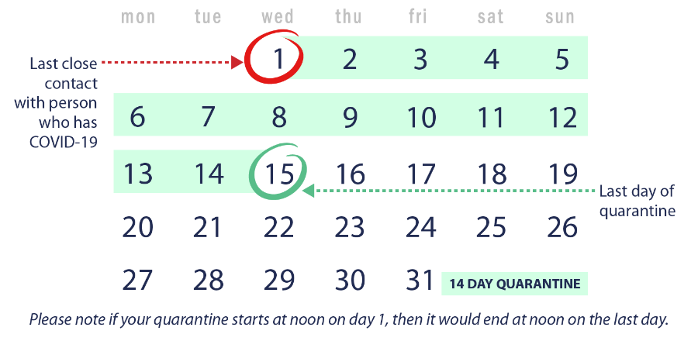
SCENARIO 2: CLOSE CONTACT WITH SOMEONE WHO HAS COVID-19—LIVE WITH THE PERSON BUT CAN AVOID FURTHER CLOSE CONTACT
I live with someone who has COVID-19 (e.g., roommate, partner, family member), and that person has isolated by staying in a separate bedroom. I have had no close contact with the person since they isolated.
Your last day of quarantine is 14 days from when the person with COVID-19 began home isolation.
Date person with COVID-19 began home isolation + 14 days = end of quarantine
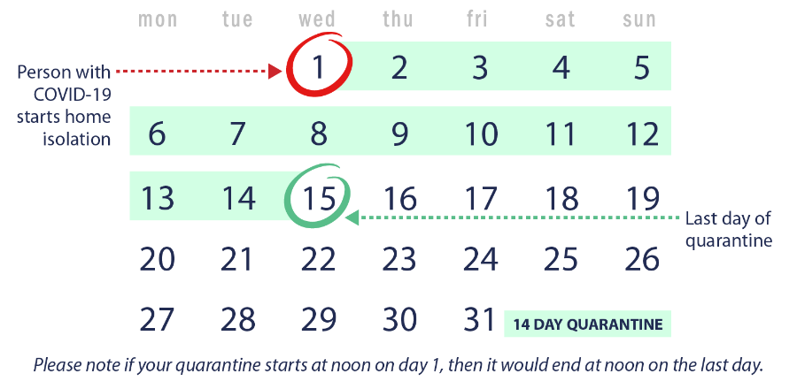

SCENARIO 3. UNDER QUARANTINE AND HAD ADDITIONAL CLOSE CONTACT WITH SOMEONE WHO HAS COVID-19
I live with someone who has COVID-19 and started my 14-day quarantine period because we had close contact. What if I ended up having close contact with the person who is sick during my quarantine? What if another household member gets sick with COVID-19? Do I need to restart my quarantine?
Yes. You will have to restart your quarantine from the last day you had close contact with anyone in your house who has COVID-19. Any time a new household member gets sick with COVID-19 and you had close contact, you will need to restart your quarantine.
Date of additional close contact with person who has COVID-19 + 14 days = end of quarantine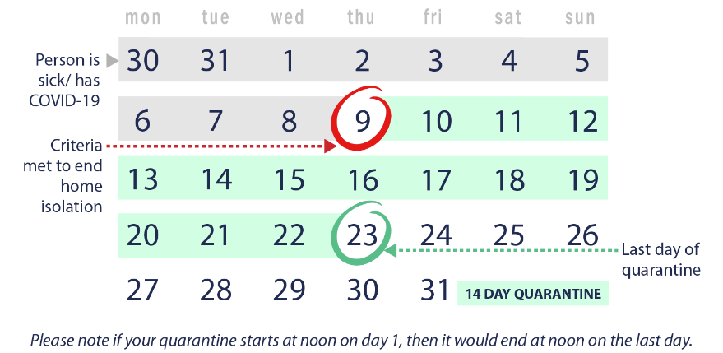
SCENARIO 4: LIVE WITH SOMEONE WHO HAS COVID-19 AND CANNOT AVOID CONTINUED CLOSE CONTACT
I live in a household where I cannot avoid close contact with the person who has COVID-19. I am providing direct care to the person who is sick, don’t have a separate bedroom to isolate the person who is sick, or live in close quarters where I am unable to keep a physical distance of 6 feet.
You should avoid contact with others outside the home while the person is sick, and quarantine for 14 days after the person who has COVID-19 meets the criteria to end home isolation.
Date the person with COVID-19 ends home isolation + 14 days = end of quarantine
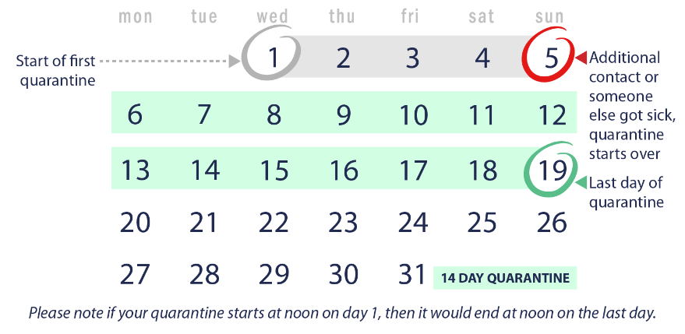

APPENDICES:

APPENDIX A: CDC GENERAL GUIDANCE FOR POSSIBLE EXPOSURE
CDC Interim Guidance for Businesses and Employers:
https://www.cdc.gov/coronavirus/2019-ncov/community/guidance-business-response.html

Public Health Recommendations for Community-Related Exposure:
https://www.cdc.gov/coronavirus/2019-ncov/php/public-health-recommendations.html

SEPARATE SICK EMPLOYEES:
- Employees who appear to have symptoms upon arrival at work or who become sick during the day should immediately be separated from other employees, customers, and visitors, and sent home. Sick employees should be directed to an isolation room if waiting for transportation.
- If unable to transport themselves, the employee may need to be transported home or to a healthcare provider. Staff should not transport any sick employee. If no transport options are available or symptoms require medical attention, call 911.
DETERMINE POSSIBLE EMPLOYEE EXPOSURE:
Employees may need to take additional precautions:
- Inform employees of their possible exposure to COVID-19 in the workplace but maintain confidentiality as required by the Americans with Disabilities Act (ADA) .
- Most workplaces should follow the Public Health Recommendations for Community-Related Exposure and instruct potentially exposed employees to stay home for 14 days, telework if possible, and self-monitor for symptoms.
- Critical infrastructure workplaces should follow the guidance on Implementing Safety Practices for Critical Infrastructure Workers Who May Have Had Exposure to a Person with Suspected or Confirmed COVID-19. Employers in critical infrastructure also have an obligation to manage potentially exposed workers’ return to work in ways that best protect the health of those workers, their co-workers, and the general public.
FACILITY CLEANING:
In most cases, if an employee is suspected or confirmed to have COVID-19 infection, we will not need to shut down our facility.
- If it has been less than 7 days since the sick employee has been in the facility, close off any areas used for prolonged periods of time by the sick person:
- Wait 24 hours before cleaning and disinfecting to minimize potential for other employees being exposed to respiratory droplets. If waiting 24 hours is not feasible, wait as long as possible.
- During this waiting period, open outside doors and windows to increase air circulation in these areas.
- If it has been 7 days or more since the sick employee used the facility, additional cleaning and disinfection is not necessary. Continue routinely cleaning and disinfecting all high-touch surfaces in the facility.
FOLLOW THE CDC CLEANING AND DISINFECTION RECOMMENDATIONS:
- Clean dirty surfaces with soap and water before disinfecting them.
- To disinfect surfaces, use products that meet EPA criteria for use against SARS-Cov-2, the virus that causes COVID-19, and are appropriate for the surface.
- Always wear gloves and gowns appropriate for the chemicals being used when you are cleaning and disinfecting.
- You may need to wear additional PPE depending on the setting and disinfectant product you are using. For each product you use, consult and follow the manufacturer’s instructions for use.

APPENDIX B: GLOSSARY

Contact = Contact with someone symptomatic during period from 48 hours before symptoms onset if the contact is with;
- Household member,
- Intimate partner,
- Individual providing care in a household without using recommended infection control precautions

Close Contact* = Contact with someone (not listed above) who is symptomatic during period from 48 hours before symptoms onset when that contact is less than 6 feet and for 15 minutes or more**

*CDC advises data is limited in defining close contact. Factors to consider include the proximity, the duration of exposure, whether the individual has symptoms (coughing likely increases exposure risk), and whether the individual was wearing a facemask (which can efficiently block respiratory secretions from contaminating others and the environment)

**CDC advises data is insufficient to precisely define the duration of time that constitutes a prolonged exposure. Recommendations vary but 15 minutes of close exposure can be used as an operational definition. Brief interactions are less likely to result in transmission; however, symptoms and the type of interaction (e.g. did the person cough directly into the face of the individual) remain important

Exposure and Potential Exposure = Those individuals having had either “Contact” or “Close Contact” with someone symptomatic from 48 hours before symptoms onset

Recovery / Recovered = At least 3 days (72 hours) have passed without symptoms, (defined as resolution of fever without the use of fever-reducing medications and improvement in respiratory symptoms (e.g., cough, shortness of breath)); and, at least 10 days have passed since symptoms first appeared.

Negative Testing = Negative results of an FDA Emergency Use Authorized COVID-19 molecular assay for detection of SARS-CoV-2 RNA from at least two consecutive respiratory specimens collected over 24 hours apart (total of two negative specimens)

APPENDIX C: EMPLOYEE RIGHTS FOR PAID SICK LEAVE UNDER FFCRA
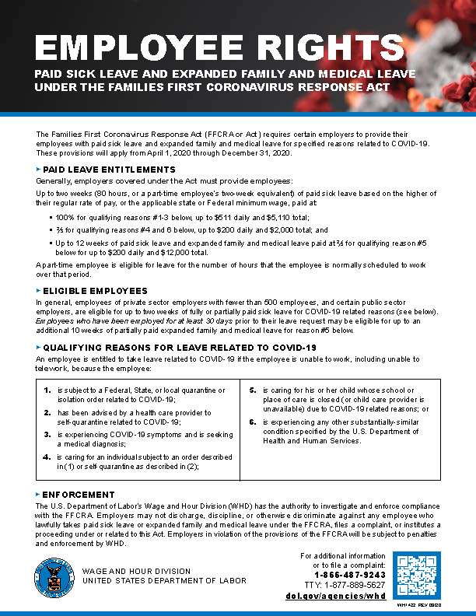

APPENDIX D: BENEFITS FOR WORKERS IMPACTED BY COVID-19
Program | Why | What | Benefits | More Information | How to File
Disability Insurance | If you’re unable to work due to medical quarantine or illness related to COVID-19 (certified by a medical professional) | Short-term benefit payments to eligible workers who have a full or partial loss of wages due to a non-work-related illness, injury, or pregnancy. | Approximately 60-70 percent of wages (depending on income); ranges from $50-$1,300 a week for up to 52 weeks. | Learn more about your eligibility for Disability Insurance | File a Disability Insurance claim
Paid Family Leave | If you’re unable to work because you are caring for an ill or quarantined family member with COVID-19 (certified by a medical professional) | Up to six weeks of benefit payments to eligible workers who have a full or partial loss of wages because they need time off work to care for a seriously ill family member. | Approximately 60-70 percent of wages (depending on income); ranges from $50-$1,300 a week for up to 6 weeks. | Learn more about your eligibility for Paid Family Leave | File a Paid Family Leave claim
Unemployment Insurance (and any extended UI benefits programs) | If you have lost your job or have had your hours reduced for reasons related to COVID-19 | Partial wage replacement benefit payments to workers who lose their job or have their hours reduced, through no fault of their own. | Range from $40-$450 per week for up to 26 weeks (plus additional weeks under extended UI benefits programs). | Learn more about your eligibility for Unemployment Insurance | File an Unemployment Insurance claim
Pandemic Unemployment Assistance | If you have lost your job or business or have had your hours or services reduced for reasons related to COVID-19 | Partial wage replacement benefit payments for business owners, self-employed, independent contractors, those who have limited work history, those who have collected all UI benefits for which they are eligible, and others not eligible for regular UI benefits who are unemployed, partially unemployed, unable to work or unavailable to work as a direct result of COVID-19. | Range from $167-$450 per week for up to 39 weeks. | Learn more about your eligibility for Pandemic Unemployment Assistance | File a Pandemic Unemployment Assistance claim
California Paid Sick Leave | If you or a family member are sick or for preventive care, including when civil authorities recommend quarantine, isolation, or stay-at-home | The leave you have accumulated or your employer has provided to you under the Paid Sick Leave law. This may be 1 hour accrued for every 30 hours worked or 3 days/24 hours provided per year; employer may cap accrual at 48 hours and use at 3 days or 24 hours, whichever is greater, within a 12 month period. | Paid to you at your regular rate of pay or an average based on the past 90 days. | Learn more about your eligibility for Paid Sick Leave | If accrued sick leave is denied, file a Wage claim
Program | Why | What | Benefits | More Information | How to File
California COVID-19 Supplemental Paid Sick Leave for Food Sector Workers (Executive Order N-51-20) | If you are a “Food Sector Worker” and are (1) subject to a governmental quarantine or isolation order related to COVID-19, (2) advised by a health care provider to self-quarantine or self-isolate due to COVID-19 concerns, or (3) are prohibited from working by the Worker’s Hiring Entity due to COVID-19-related health concerns. | Up to 80 hours of supplemental paid sick leave for Food Sector Workers who work for hiring entities with 500 or more employees in the United States. | Paid to you at your regular rate of pay, the state minimum wage, or the local minimum wage, whichever is higher. | Learn more about your eligibility for COVID-19 Supplemental Paid Sick Leave for Food Sector Workers | If COVID-19 Supplemental Paid Sick Leave is denied, file a Wage claim
Federal Families First Coronavirus Response Act (FFCRA) Emergency Paid Sick Leave | If you are unable to work (or telework) because:  (1) You are subject to a Federal, State, or local quarantine or isolation order related to COVID-19.  (2) You have been advised by a health care provider to self-quarantine due to concerns related to COVID-19.  (3) You are experiencing symptoms of COVID-19 and seeking a medical diagnosis.  (4) You are caring for an individual who is subject to an order as described in subparagraph (1) or has been advised as described in paragraph (2).  (5) You are caring for a child whose school or place of care has been closed, or whose child care provider is unavailable, for reasons related to COVID-19  (6) You are experiencing any other substantially similar condition specified by the Secretary of Health and Human Services. | Up to 80 hours of paid sick leave for employees who work for public employers, or for private employers with fewer than 500 employees. (Some exceptions may apply, including small business exemption from providing paid leave for child care.) | For employee: Higher of regular rate or minimum wage rate, not to exceed $511 per day and $5,110 in total  For family care: 2/3 of regular rate, not to exceed $200 per day and $2,000 in total | Learn more about your eligibility for FFCRA Emergency Paid Sick Leave | If paid sick leave is denied, you may file a FFCRA Emergency Paid Sick Leave claim
Program | Why | What | Benefits | More Information | How to File
Federal Families First Coronavirus Reponse Act (FFCRA) Emergency Paid Family & Medical Leave | If you are unable to work (or telework) because you are caring for a child whose school or place of care has been closed, or whose child care provider is unavailable, for reasons related to COVID-19. | Up to an additional 10 weeks of paid leave for employees who work for public employers or private employers with fewer than 500 employees. (Small business exemption may apply) | 2/3 of regular rate, not to exceed $200 per day and $10,000 total | Learn more about your eligibility for FFCRA Emergency Paid Family & Medical Leave | If paid leave for child care is denied, you may file a FFCRA Emergency Paid Family & Medical Leave claim
Local Government Supplemental Paid Sick Leave for COVID-19 | If you live in the city of Los Angeles, unincorporated areas of Los Angeles County, San Francisco, or San Jose, you may be eligible for supplemental paid sick leave for COVID-19-related reasons if you are not covered by the FFCRA. | Up to 80 hours of supplemental paid sick leave for covered employees. | Varies by locality. |  | Varies by locality.
 |  |  |  | LA City
 |  |  |  | Unincorporated LA County
 |  |  |  | San Francisco
 |  |  |  | San Jose
Workers’ Compensation | If you reported to your employer’s worksite between March 19 and July 5, 2020 and tested positive or were diagnosed with a COVID-19-related illness, you may be eligible for workers’ compensation benefits under the Executive Order issued by Governor Newsom on May 6. | Under the Executive Order you may receive temporary disability (TD) payments after exhausting specific federal or state COVID-19 paid sick leave benefits. You may be entitled to TD payments for up to 104 weeks. TD payments stop when either you return to work, your doctor releases you for work, or your doctor says your illness has improved as much as it’s going to. | TD generally pays two-thirds of the gross wages you lose while you are recovering from a work-related illness or injury, up to maximum weekly amount set by law. In addition, eligible employees are entitled to medical treatment and additional payments if a doctor determines you suffered a permanent disability because of the illness. | Learn more about your eligibility for Workers’ Compensation benefits | File a Workers’ Compensation claim

APPENDIX E: SYMPTOM SCREENING CHECKLIST
